|  |  |
| --- | --- |
| UDC (UO‘K, УДК) number |  |

TITLE OF THE ARTICLE (SHOULD BE CENTERED IN 14 POINT BOLD FONT IN CAPITAL LETTERS. PLEASE DO NOT CHANGE THIS FORMAT)

|  |  |  |  |
| --- | --- | --- | --- |
| Businessman - Free social icons | Businessman - Free social icons | Businessman - Free social icons | Businessman - Free social icons |
| *Last name First name* | *Last name First name* | *Last name First name* | *Last name First name* |
| *Scientific title, place of work, email address*  *ORCID ID number* | *Scientific title, place of work, email address*  *ORCID ID number* | *Scientific title, place of work, email address*  *ORCID ID number* | *Scientific title, place of work, email address*  *ORCID ID number* |

*Abstract. The abstract should be in the given form and appearance. Please do not modify this form. The abstract should consist of 100-250 words and 4-20 keywords. Abstract and keywords must be provided in Uzbek, Russian and English (in 3 languages) to be indexed in international systems.*

***Keywords:*** *here it is appropriate to write terms that received the main emphasis in an article of 4-20 words.*

НАЗВАНИЕ СТАТЬИ (ДОЛЖНО БЫТЬ ВЫДЕЛЕНО ПО ЦЕНТРУ ЖИРНЫМ ШРИФТОМ 14 ПУНКТОВ И ЗАГЛАВНЫМИ БУКВАМИ. ПОЖАЛУЙСТА, НЕ МЕНЯЙТЕ ЭТОТ ФОРМАТ)

|  |  |  |  |
| --- | --- | --- | --- |
| Businessman - Free social icons | Businessman - Free social icons | Businessman - Free social icons | Businessman - Free social icons |
| *Фамилия Имя* *Отчества* | *Фамилия Имя* *Отчества* | *Фамилия Имя* *Отчества* | *Фамилия Имя* *Отчества* |
| *Научное звание, место работы, адрес электронной почты* | *Научное звание, место работы, адрес электронной почты* | *Научное звание, место работы, адрес электронной почты* | *Научное звание, место работы, адрес электронной почты* |

*Аннотация. Аннотация должна быть в заданном виде и оформлении. Пожалуйста, не изменяйте эту форму. Аннотация должна состоять из 100-250 слов и 4-20 ключевых слов. Аннотация (ABSTRACT на английском языке) и ключевые слова должны быть предоставлены на узбекском, русском и английском языках (на 3 языках) для индексации в международных системах.*

***Ключевые слова:*** *здесь уместно написать термины, получившие основной акцент в статье из 4-20 слов.*

MAQOLANING NOMI (14 O‘LCHAMDA QALIN, KATTA HARFLI FORMATDA O‘RTADA JOYLASHISHI LOZIM. ILTIMOS, BU SHAKLNI O‘ZGARTIRMANG)

|  |  |  |  |
| --- | --- | --- | --- |
| Businessman - Free social icons | Businessman - Free social icons | Businessman - Free social icons | Businessman - Free social icons |
| *Famiya Ism Sharif* | *Famiya Ism Sharif* | *Famiya Ism Sharif* | *Famiya Ism Sharif* |
| *Ilmiy unvoni, ish joyi, electron pochta manzili* | *Ilmiy unvoni, ish joyi, electron pochta manzili* | *Ilmiy unvoni, ish joyi, electron pochta manzili* | *Ilmiy unvoni, ish joyi, electron pochta manzili* |

*Annotatsiya. Annotatsiya berilgan shakl va ko‘rinishda bo‘lishi lozim. Iltimos, bu shaklni o‘zgartirmang. Annotatsiya 100-250 so‘zdan hamda 4-20 kalit so‘zlardan iborat bo‘lishi lozim. Annotatsiya (ingliz tilida ABSTRACT) va kalit so‘zlar (keywords) xalqaro tizimlarda indekslanishi uchun (3 ta tilda) o‘zbek, rus va ingliz tilida ham berilishi zarur.*

***Kalit so‘zlar:*** *bu yerga 4-20 so‘zdan iborat maqoladagi asosiy urg‘u olgan atamalarni yozish maqsadga muvofiq.*

**Introduction.** This section contains the introduction to the article. Size 14, Times New Roman. This section contains the introduction to the article. Size 14, Times New Roman. This section contains the introduction to the article. Size 14, Times New Roman. This section contains the introduction to the article. Size 14, Times New Roman. This section contains the introduction to the article. Size 14, Times New Roman. This section contains the introduction to the article. Size 14, Times New Roman. This section contains the introduction to the article. Size 14, Times New Roman. This section contains the introduction to the article. Size 14, Times New Roman.

**Methods.** The next section describes the analysis of literature and methods of work. Size 14, Times New Roman. The next section describes the analysis of literature and methods of work. Size 14, Times New Roman. The next section describes the analysis of literature and methods of work. Size 14, Times New Roman. The next section describes the analysis of literature and methods of work. Size 14, Times New Roman. The next section describes the analysis of literature and methods of work. Size 14, Times New Roman. The next section describes the analysis of literature and methods of work. Size 14, Times New Roman. The next section describes the analysis of literature and methods of work. Size 14, Times New Roman.

Table 1

***The table title is written here (do not change the format. Table formatting is optional)***

|  |  |  |
| --- | --- | --- |
| Title naming | Title naming | Title naming |
| Table structure | Table structure | Table structure |
| Table structure | Table structure | Table structure |
| Table structure | Table structure | Table structure |

**Results.** This section may contain results related to the article (tables, graphs, diagrams, etc.). Size 14, Times New Roman. This section may contain results related to the article (tables, graphs, diagrams, etc.). Size 14, Times New Roman.

This section may contain results related to the article (tables, graphs, diagrams, etc.). Size 14, Times New Roman.

This section may contain results related to the article (tables, graphs, diagrams, etc.). Size 14, Times New Roman.

This section may contain results related to the article (tables, graphs, diagrams, etc.). Size 14, Times New Roman.

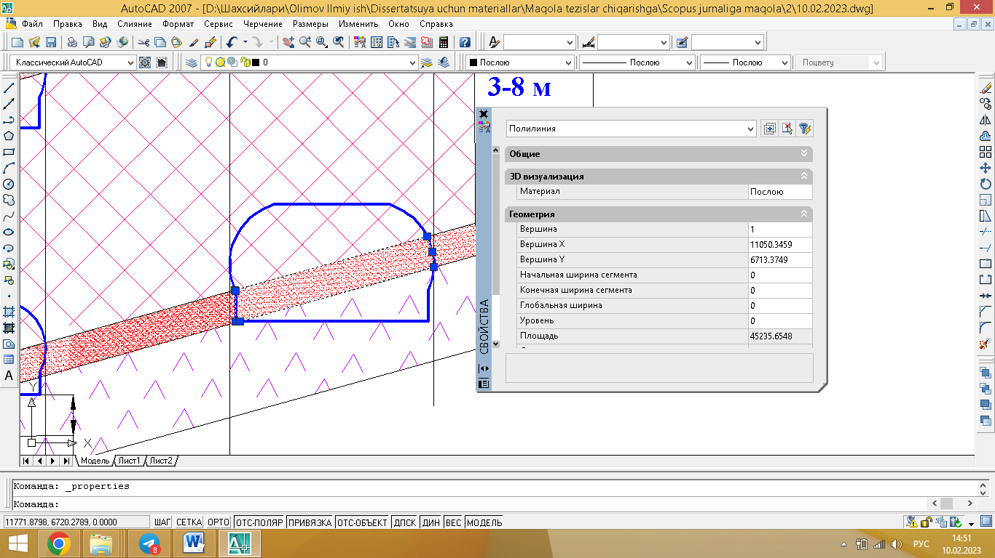

***Figure 1. Position of solder relative to the mineral layer (example image).***

**Discussion.** This section presents a discussion of the results and challenges. Size 14, Times New Roman font, divided into separate paragraphs. If there are subheadings in the discussion section, they are written in 14-point bold Times New Roman font and placed in a separate paragraph.

This section presents a discussion of the results and challenges. Size 14, Times New Roman font, divided into separate paragraphs. If there are subheadings in the discussion section, they are written in 14-point bold Times New Roman font and placed in a separate paragraph.

This section presents a discussion of the results and challenges. Size 14, Times New Roman font, divided into separate paragraphs. If there are subheadings in the discussion section, they are written in 14-point bold Times New Roman font and placed in a separate paragraph.

This section presents a discussion of the results and challenges. Size 14, Times New Roman font, divided into separate paragraphs. If there are subheadings in the discussion section, they are written in 14-point bold Times New Roman font and placed in a separate paragraph.

This section presents a discussion of the results and challenges. Size 14, Times New Roman font, divided into separate paragraphs. If there are subheadings in the discussion section, they are written in 14-point bold Times New Roman font and placed in a separate paragraph.

***Graph 1. Solder placement graph depending on solder cross-section and layer coverage (example graph).***

**Conclusions.** This section presents the full content of the article. Size 14, Times New Roman font, divided into separate paragraphs. If there are subheadings in the annotation, they are written in 14 point, bold Times New Roman font, and separated into a separate paragraph.

This section presents the full content of the article. Size 14, Times New Roman font, divided into separate paragraphs. If there are subheadings in the annotation, they are written in 14 point, bold Times New Roman font, and separated into a separate paragraph.

This section presents the full content of the article. Size 14, Times New Roman font, divided into separate paragraphs. If there are subheadings in the annotation, they are written in 14 point, bold Times New Roman font, and separated into a separate paragraph.

REFERENCES

1. Тиловов А. Камера №85, Панел №7, Н-II-а, Комб-131 Лаҳимининг қатламга нисбатан жойлашув схемалари. Ўзб. 2022. 4-с
2. ШР Уринов, СА Мансурова, НА Боймуродов, КА Ахмедов, МБ Мирзахмедов, ШТ Ярашов. УСТОЙЧИВОСТИ БОРТОВ КАРЬЕРА С УЧЕТОМ ВРЕМЕННОГО ФАКТОРА. Sanoatda raqamli texnologiyalar/Цифровые технологии в промышленности: Volume 1, Issue 1, Pages 56-63, 2023/9. DOI: 10.5281/zenodo.8360842 <https://cyberleninka.ru/article/n/ustoychivosti-bortov-kariera-s-uchetom-vremennogo-faktora>
3. G.Bakirov, H.Abdishukurovich, & X.Nurxonov. (2023). ASSESSMENT OF THE WORKING CONDITIONS OF A METAL FRAME REINFORCED BENDER AND CONTROL OF ITS MODE. Sanoatda raqamli texnologiyalar, 1(1), 64–70. <https://doi.org/10.5281/zenodo.8374187>

***\**** ***Explanation.*** *The above list of references is given as an example. If you want to improve your* ***Google Scholar*** *citation and h-index, please provide the correct citation address for your article in Google Scholar or use the example above.* ***Attention!*** *Do not change the article template and literature placement format.*

***Reminder!*** *It is necessary to provide a report confirming the originality of the article (anti-plagiarism) (the article is accepted if the originality level is 65 percent or higher and meets the above requirements, as well as in the absence of grammatical errors). Anti-plagiarism address: <https://antiplag.uz/>*

***Phone for information: 90 673 64 33***

***Telegram address:*** [*http://t.me/kmurojaat_livebot*](http://t.me/kmurojaat_livebot)

***Web site:*** [*www.srt-journal.uz*](http://www.srt-journal.uz)

